E
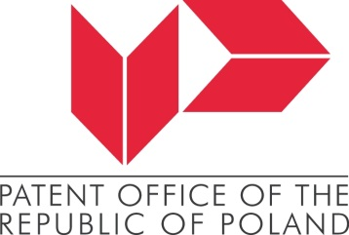
Session
WIPO/2021/PROV.1
ORIGINAL: ENGLISH
DATE: NOVEMBER 29, 2021

Videogames and their Uniting Power.

Everything you need to know about enabling environments and new trends.

the World Intellectual Property Organization (WIPO)

and
the Patent Office of the Republic of Poland

Katowice (hybrid), December 8, 2021

Provisional program

prepared by the International Bureau

Wednesday, December 8, 2021

12.00 – 12.02 Movie on IP and Videogames
12.02 – 12.05 Welcome
Ms. Edyta Demby-Siwek, President, Patent office of the Republic of Poland, Warsaw
12.05 – 12.08 Introduction by Moderators
Ms. Anna Dachowska, Director, International Cooperation, PPO
Mr. Rafael Ferraz Vazquez, Copyright Law Division, Copyright and Creative Industries Sector, WIPO
12.08 – 12.20 Topic 1: Never stop growing: Will the videogame industry continue to grow?
Ms. Andreea Medvedovici Per, Vice-President, European Game Developers Federation (EGDF), Bucharest
Q&A
12.20 – 12.55 Topic 2: The circle of IP: How is IP created and shared in videogames and beyond?
Ms. Deborah Papiernik, SVP New Business & Strategic Alliances, Ubisoft, Paris
Ms. Anna Piechówka, Senior Legal Counsel, IP, Business & Marketing, CD Projekt Red, Warsaw
Ms. Masha Stolbova, Head of Legal, Natus Vincere, Kyiv
Q&A
12.55 – 13.15 Topic 3: What are the main challenges or opportunities today and in the future?
Dr. Andres Guadamuz, Senior Lecturer in IP Law, University of Sussex, Editor in Chief of the Journal of World Intellectual Property, Sussex, UK
Mr. Olivier Piasentin, Founder, Ikimasho, Paris
Q&A
13.15 – 13.20 What’s next in WIPO?
Mr. Dimiter Gantchev, Deputy Director and Senior Manager, Information and Digital Outreach Division, Copyright and Creative Industries Sector
13.20 – 13.30 Open debate and conclusion

